# Overview-Bootstrap

## Full stack development

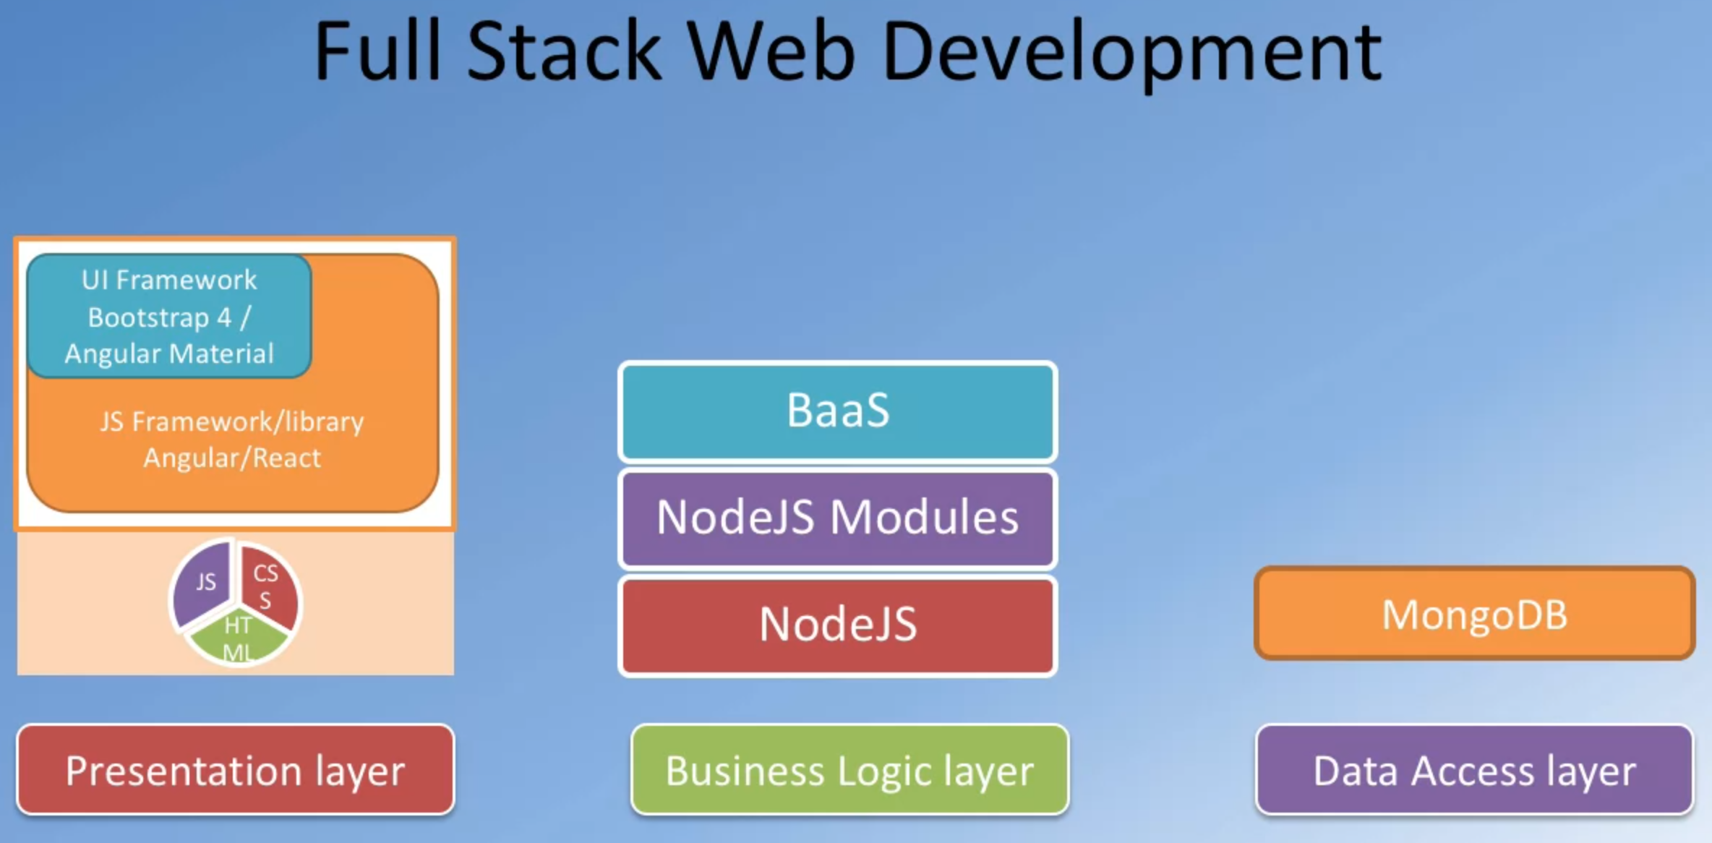

The full stack developing can be described as three layers:

1. Presentation Layer (Concerned with UI related issues)
2. Business Logic Layer (Data validation, dynamic content processing)
3. Data Access layer (Data persistence data access through an API)

Traditionally, we use the following structure for those three layers.

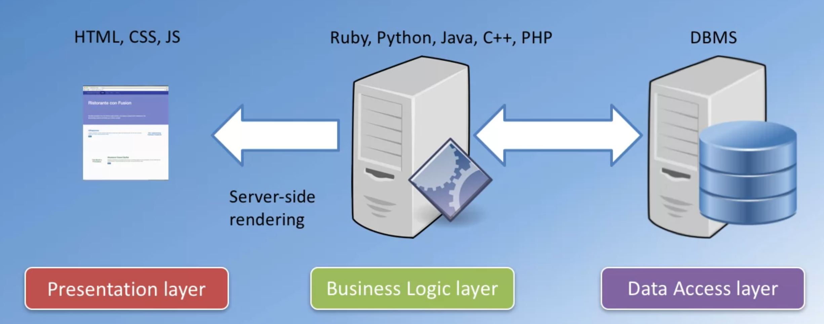

However, there is a trend to use JavaScript (one language) to handle all parts, as follows

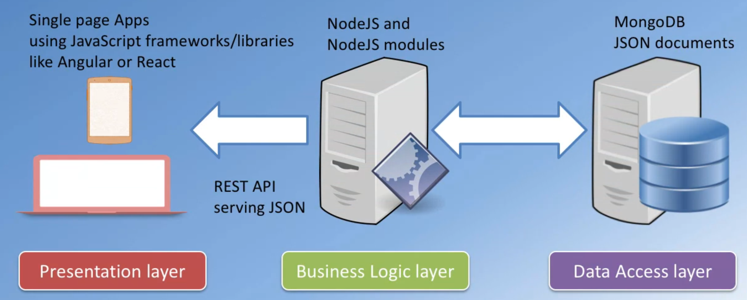

## Front-end Web UI Frameworks

It is a collection of ready-to-use HTML, CSS and JavaScript templates for UI components, includes typography, forms, buttons, tables, navigations, dropdowns, alerts, modals, tabs, accordion, carousel.

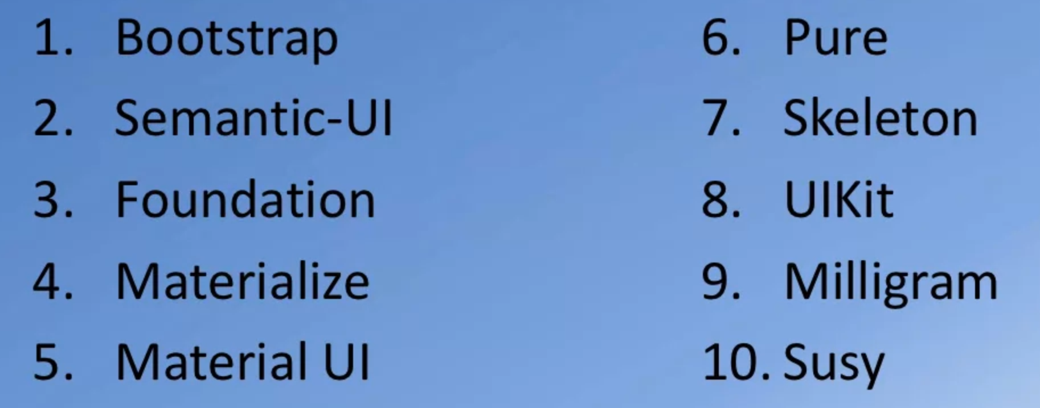

## Install Bootstrap using NPM

Using command “npm install [bootstrap@4.0.0](mailto:bootstrap@4.0.0) --save” to install specific version of bootstrap, and we will find it requires two libraries to support, jquery and popper.js, use command “npm install [jquery@3.3.1](mailto:jquery@3.3.1) [popper.js@1.12.9](mailto:popper.js@1.12.9) --save”

## Import Bootstrap module into our website

1. Import the css part

 <!-- Bootstrap CSS -->

 <link rel="stylesheet" href="node_modules/bootstrap/dist/css/bootstrap.min.css">

1. Import JS part, since bootstrap is supported by JQuery and popper.JS, we need to import those two first

<!-- jQuery first, then Popper.js, then Bootstrap JS. -->

<script src="node_modules/jquery/dist/jquery.slim.min.js"></script>

<script src="node_modules/popper.js/dist/umd/popper.min.js"></script>

<script src="node_modules/bootstrap/dist/js/bootstrap.min.js"></script>

# Bootstrap Features

## Media Queries (responsive design)

Auto-reshape the css style based on the size of viewpoint

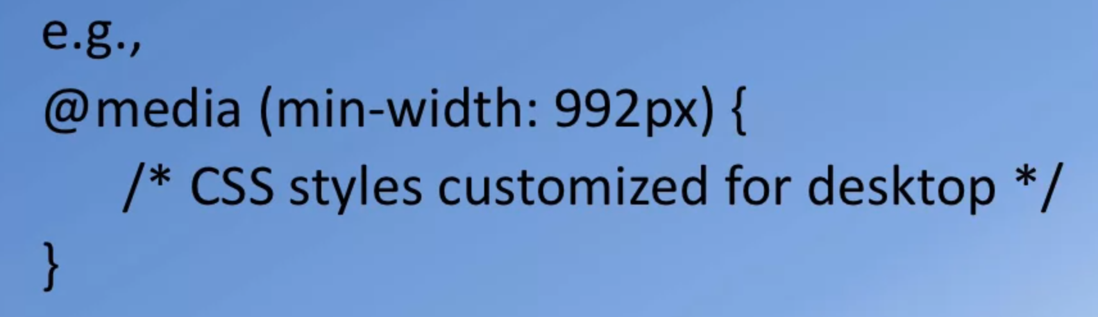

## Grid System

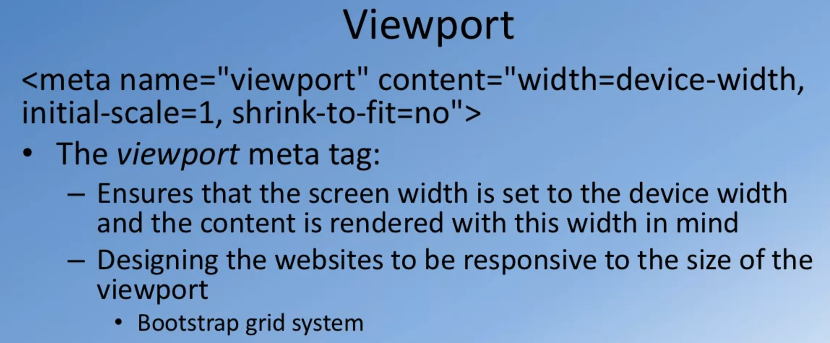

### Classes for grid system

1. Define the outermost class as **container** (or container-fluid)
2. Inside of container, we could use **row** class (divided into 12 equal sized columns)
3. Inside of row, we could use **column** class (five available class)
   1. Default value applies to all screen sizes from extra small to extra-large **(col-*)**
   2. Sm for small **(col-sm-*)**
   3. Md for medium **(col-md-*)**
   4. Lg for large **(col-lg-*)**
   5. Xl for extra large screen size **(col-xl-*)**

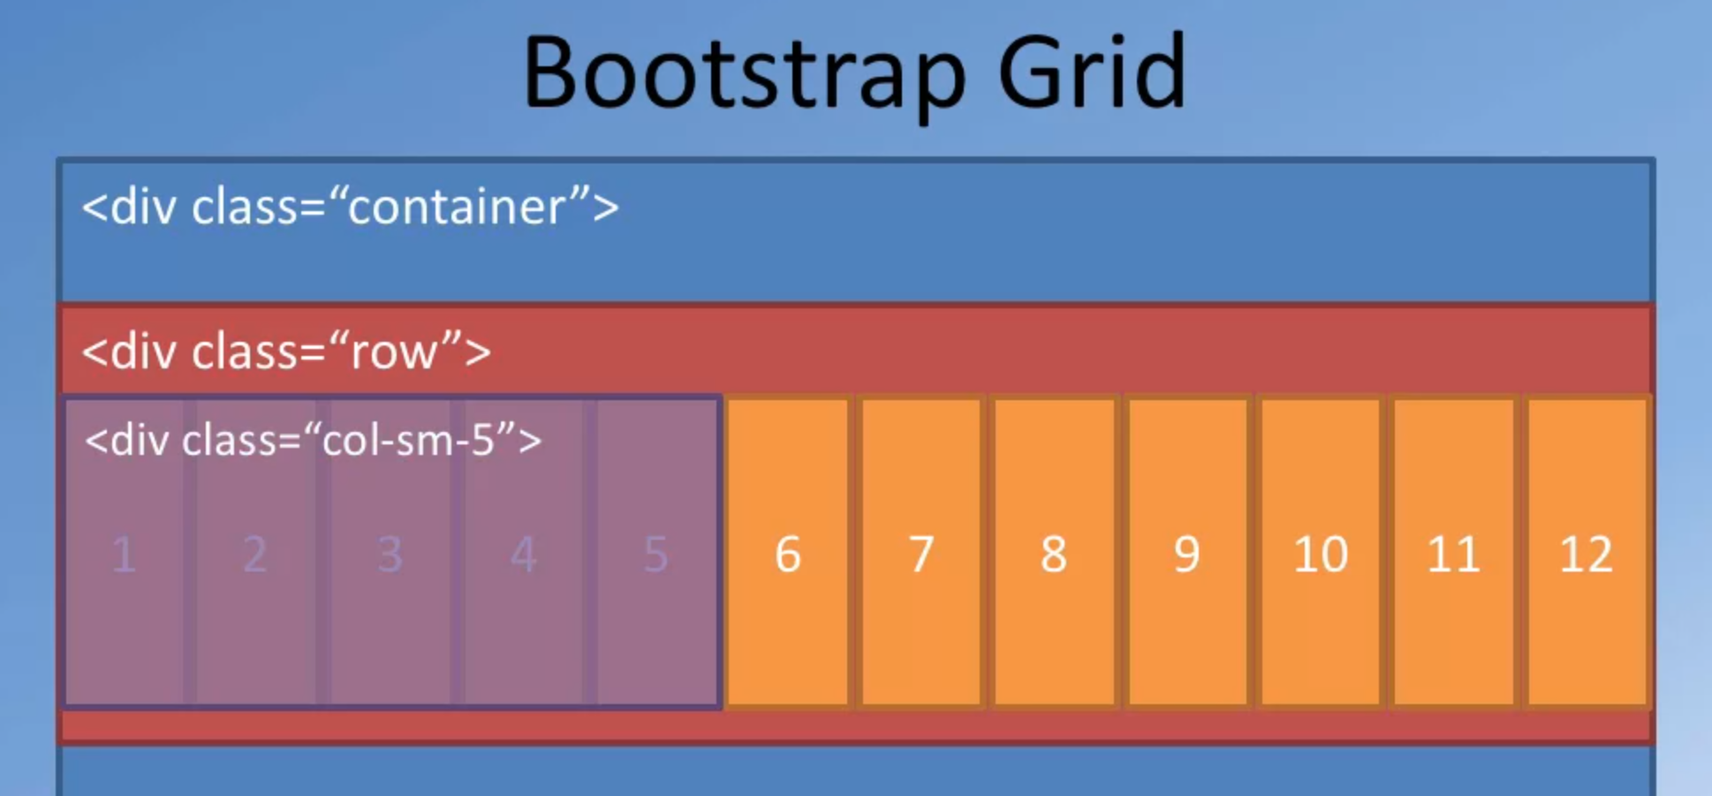

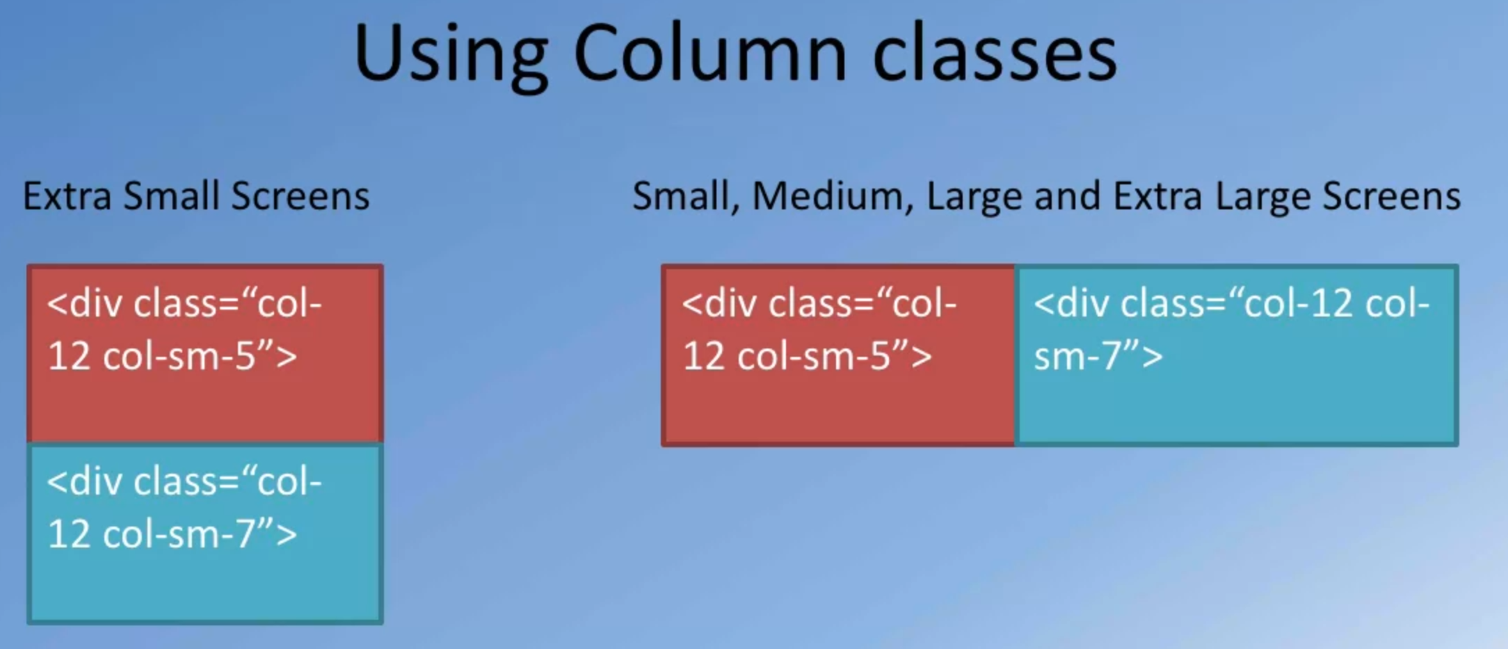

### Reordering Content

We could also use “order-*-first/last” to specific the position of our content

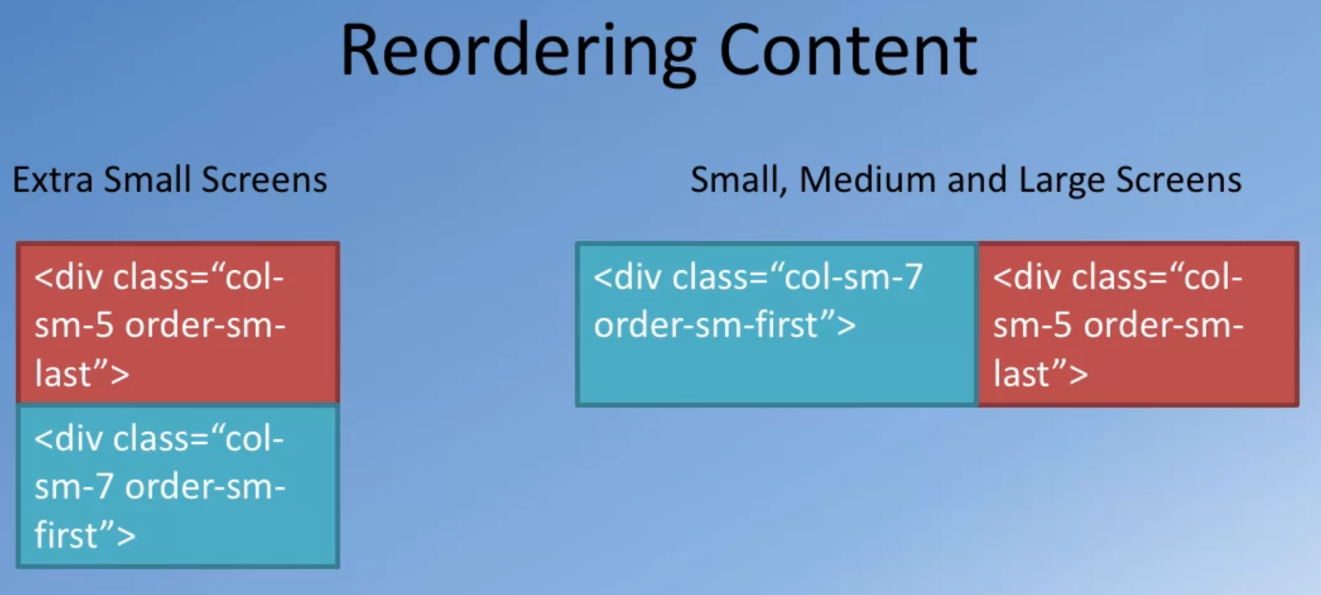

### Vertical and horizontal alignment

Use class “**align-items-center**” to vertically layout the content (for row class)

For column class, use **“align-self-center”**

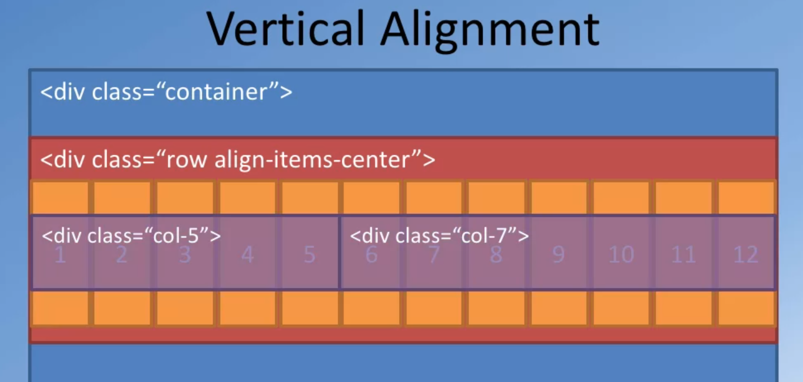

If you want horizontally to align your elements, use **“justify-content-center”.** Or **“text-center”** for text

### Column offsets

Use class “**offset-*-\***” to set the offset

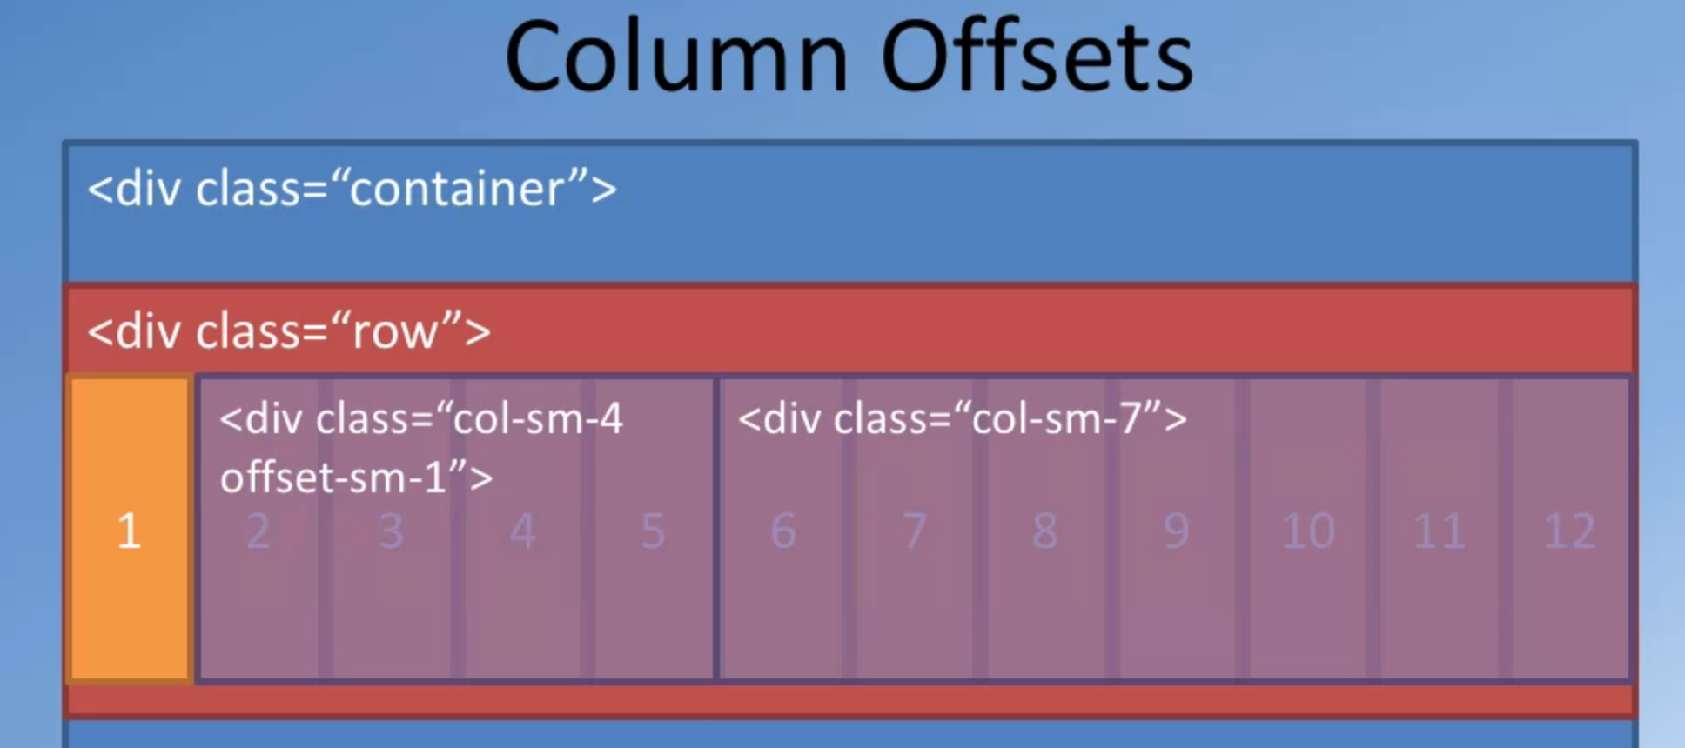

### Nesting Columns

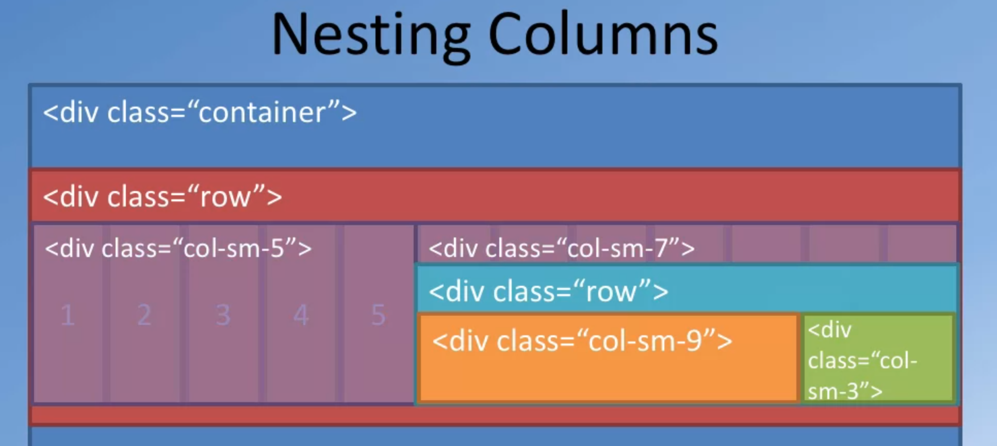

## Header: jumbotron

The **jumbotron** class would set apart the content inside the jumbotron from the rest of the page.

## List: unstyled

Use **“<ul class = “list-unstyled”>”** to remove the default style of list elements

## D-None and DSM Block

Sometimes, we want to hide some content for extra-small screen size, in this case, we use “d-none d-*-block”

For example

<div class="d-none d-sm-block">

<p>Award winning three-star Michelin chef with wide International experience having worked closely with whos-who in the culinary world, he specializes in creating mouthwatering Indo-Italian fusion experiences. He says, <em>Put together the cuisines from the two craziest cultures, and you get a winning hit! Amma Mia!</em></p>

</div>